Instruction Manual

Peripheral Arterial Disease (PAD) Software
Dr Ambikesh Jayal, ambi1999@gmail.com 31 July 2020

This software performs Biomedical signal analysis of arterial pulse volume waveforms (PVW) in diabetics. This software has been developed by Dr Ambikesh Jayal. The copyrights for this software belong to Health Care Diagnostic Solutions Ltd.

Video Demonstration and Screenshot

Video Demonstration of software is available at https://youtu.be/cmIe_MMKUcQ
Screenshots
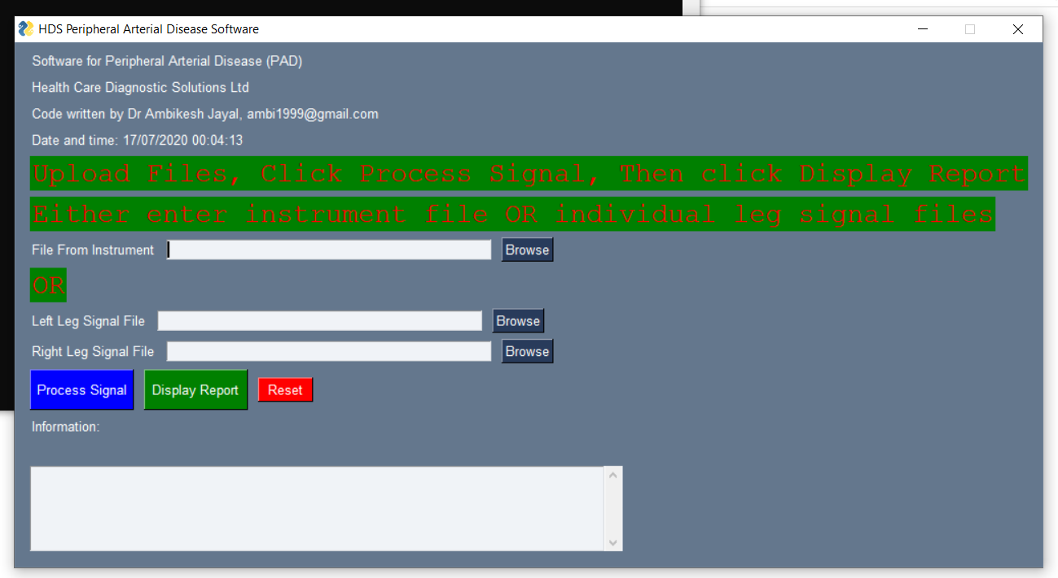
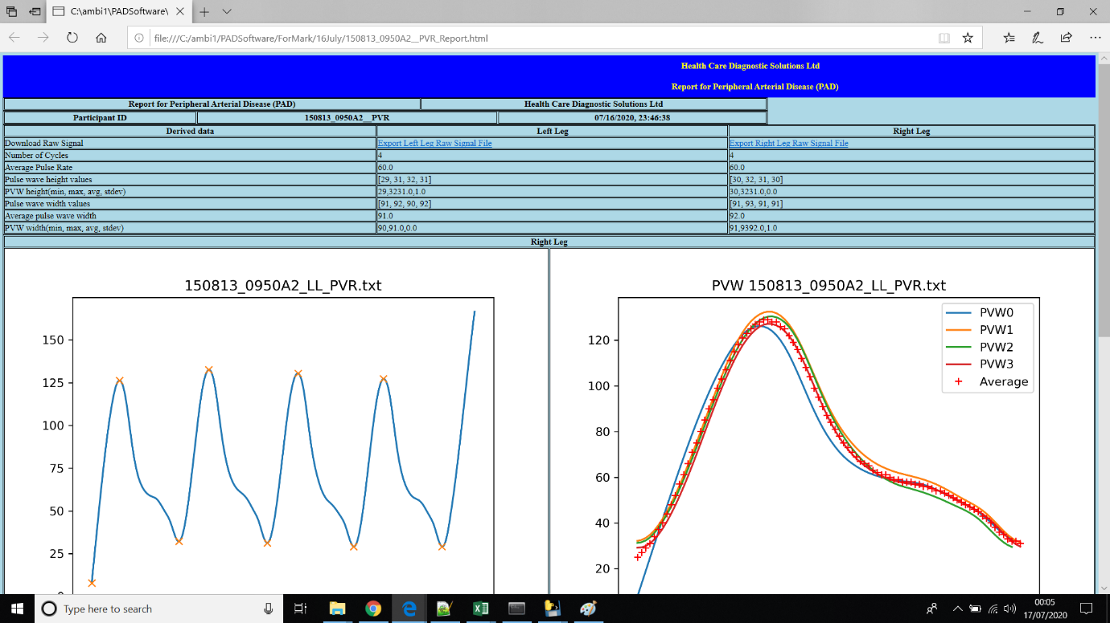

2. Executable Software
The zip file ‘PADSoftwarev19.zip’ contains the software. Download this zip file. Simply unzip it and double click the exe file to run. You will see a GUI. I have also attached the test data in the zip file that you can use for running the software. Input the instrument file and click the process signal button, after a few seconds click the Display report button. The report will open in a browser.
The software zip file ‘PADSoftwarev19.zip’ contains two files, first is the executable software and second is reporttemplate.html. Keep both these files in same folder. I have created reporttemplate so that we can reports can be easily customised in future.

3. Source Code
The source code is available in the source code folder both as a python file and a Jupyter Notebook. This folder contains two files namely PVWSoftware_v19.py and PVWSoftware_v19.ipynb.

4. Contacting Developer
Developer for this software can be contacted at email below
Dr Ambikesh Jayal, ambi1999@gmail.com
Website: https://sites.google.com/site/ambi1999
Linkedin: https://uk.linkedin.com/in/ambikesh-jayal-78aa4718

